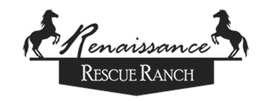
RENAISSANCE RESCUE RANCH

Thank you for sponsoring a horse in need. You can sponsor the horse(s) of your choice online or through the mail. To make your donation by mail, please print out this form and fill out the requested information. This form is for Sponsorships only.

SPONSORSHIP FORM

First Name ___________________Last Name__________________________

Address ______________________________________________________

City ____________________________ State _________ Zip _____________

Phone _____________ E-Mail _____________________________________

I would like to sponsor:

Horse’s Name Amount

_________________________ $______________

If you wish to support a horse and pay monthly, please fill out the following:

I would like to sponsor ___________________ on a monthly basis @ $_______/month for ______ months.

If you are sponsoring “in memory of”/”in honor of someone”, please leave their name & address if you would like us to send them a note about the sponsorship.

__________________________________________________________

__________________________________________________________

Please choose one of the following payment options:

􀁔 Payment by mail – please send your check payable to Renaissance Rescue Ranch with this form to:
Sponsorships
Renaissance Rescue Ranch
4305 Highway O
Farmington, Missouri 63640

􀁔 Payment via PayPal – Click on the PayPal link on our Sponsorship page. Please be sure to add your Sponsorship information in your PayPal transaction notes.

Thank you!

Renaissance Rescue Ranch is a federal 501 (c) 3 not for profit corporation dedicated to helping horses in need.
All sponsorships and other donations are tax deductible to the fullest extent of the law.

